
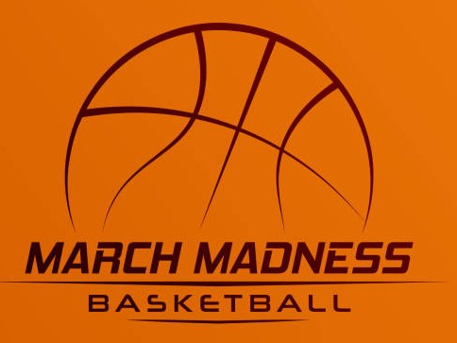
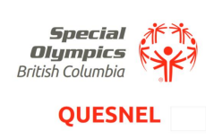

1st ever MARCH MADNESS NORTH
Basketball tournament

Date: February 28th and March 1st, 2026
Tip-off: 9:30am Saturday, 9am Sunday

Registration fee: $450 per team. This includes:
- Venue rental for Saturday and Sunday
- Commemorative T-shirt for each athlete and coach
- Lunches on Saturday and Sunday
- Prizes

Venue: Quesnel Junior School, 950 Mountain Ash Road, Quesnel, V2J 3V7

Format: Depends on the number of teams entered…
Five or fewer teams will play a round robin format with a single playoff game
Six or more teams will play a divisioning round, then round-robin games within their divisions, followed by crossover playoff semi-finals and a final

An optional team skills competition will take place on Saturday afternoon. Willing participants will be grouped by ability; each team will then have a volunteer coach or community member join by random draw. Coaches are encouraged to participate; minimal exercise will be involved…

This competition will follow SOC basketball rules as posted on the SOBC website…

Lunch will be provided on Saturday and Sunday. Breakfast will be available for purchase on site. Please note any dietary restrictions and we will do our best to accommodate. Individual coaches will be advised of any issues…

Coaches MUST always have current medical forms for their athletes and volunteers with them.

Roster size: Minimum (8), Maximum (10)

Registration deadline: February 13th, 2026… Please submit registration form to:
Rick Prosk
Program Coordinator
rprosk@telus.net

Contact information:
- Rick Prosk (250-992-2741, 250-255-7072 [cell], rprosk@telus.net)
- Sam Wright, Head coach (250- 991-6373. samantha.wright@westfraser.com)
- Sue Kent, head coach (250-991-3342, sqkent@outlook.com)

BASKETBALL TOURNAMENT REGISTRION FORM

Team Name: ___________________________________ Local: ___________________
Team Contact: __________________________________________
Phone: ________________________ (cell) E-mail: ____________________________
TEAM ROSTER
Athlete’s name | GENDER  (M/F/X) | Date of birth  (MM/DD/YY) | ABILITY LEVEL  A, B, C | UNISEX T-shirt size | Interested in team skills competition?*
1.
2.
3.
4.
5.
6.
7.
8.
9.
10.
Coach’s name |  |  |  | UNISEX T-shirt size | Interested in team skills competition?*
1.
2.
3.
* Final decisions on participation in the skills competition can be made on February 28th

